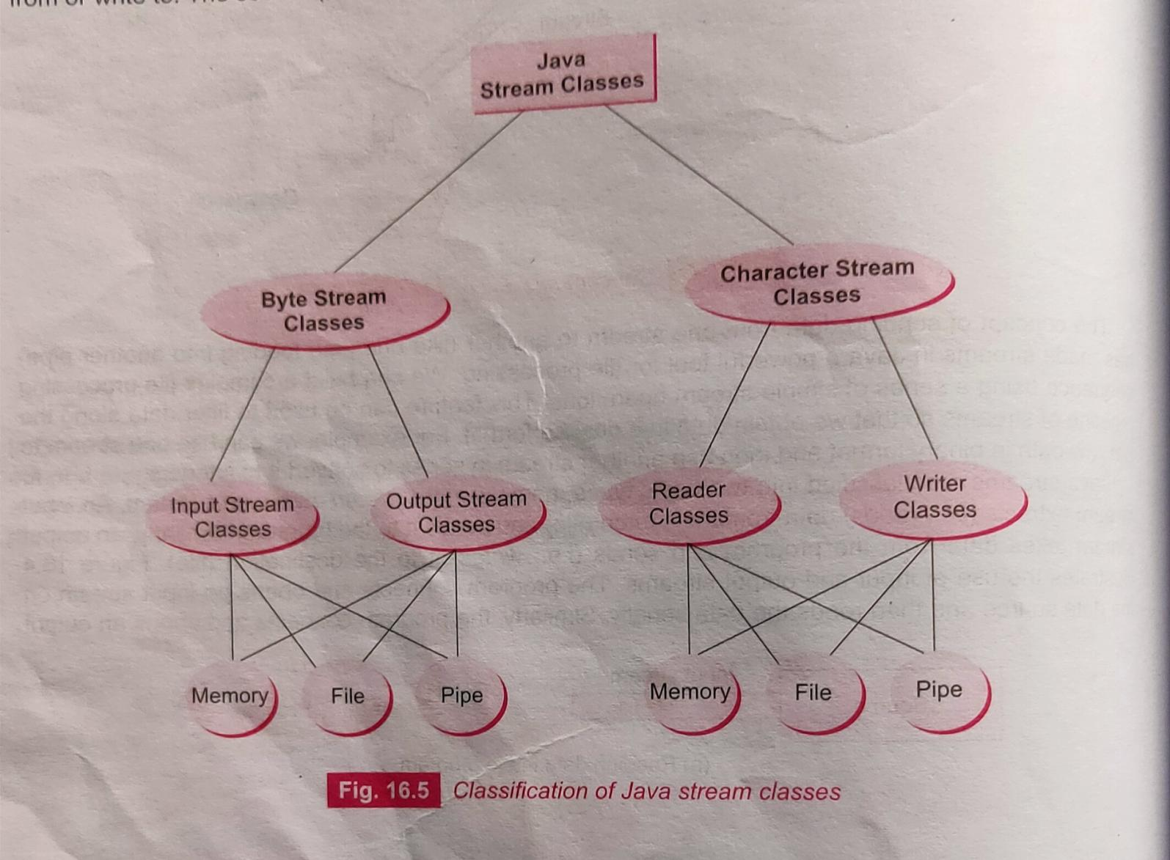

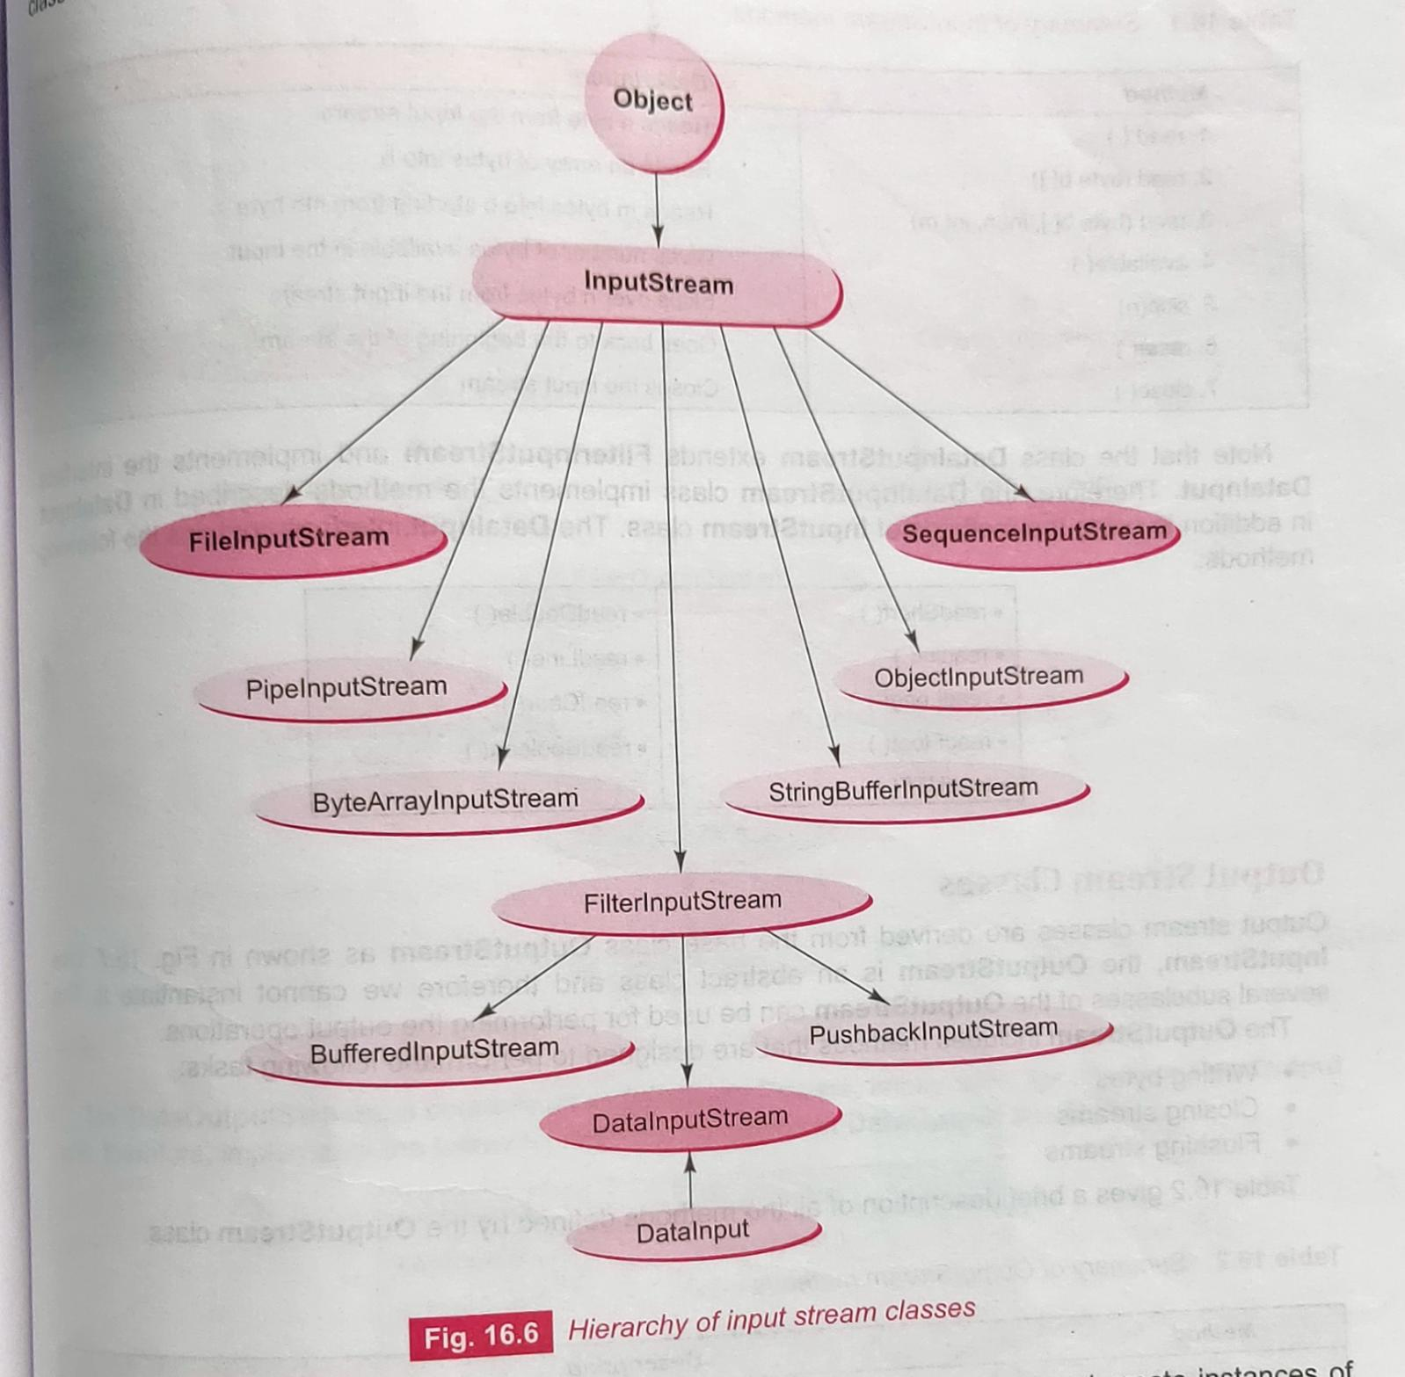

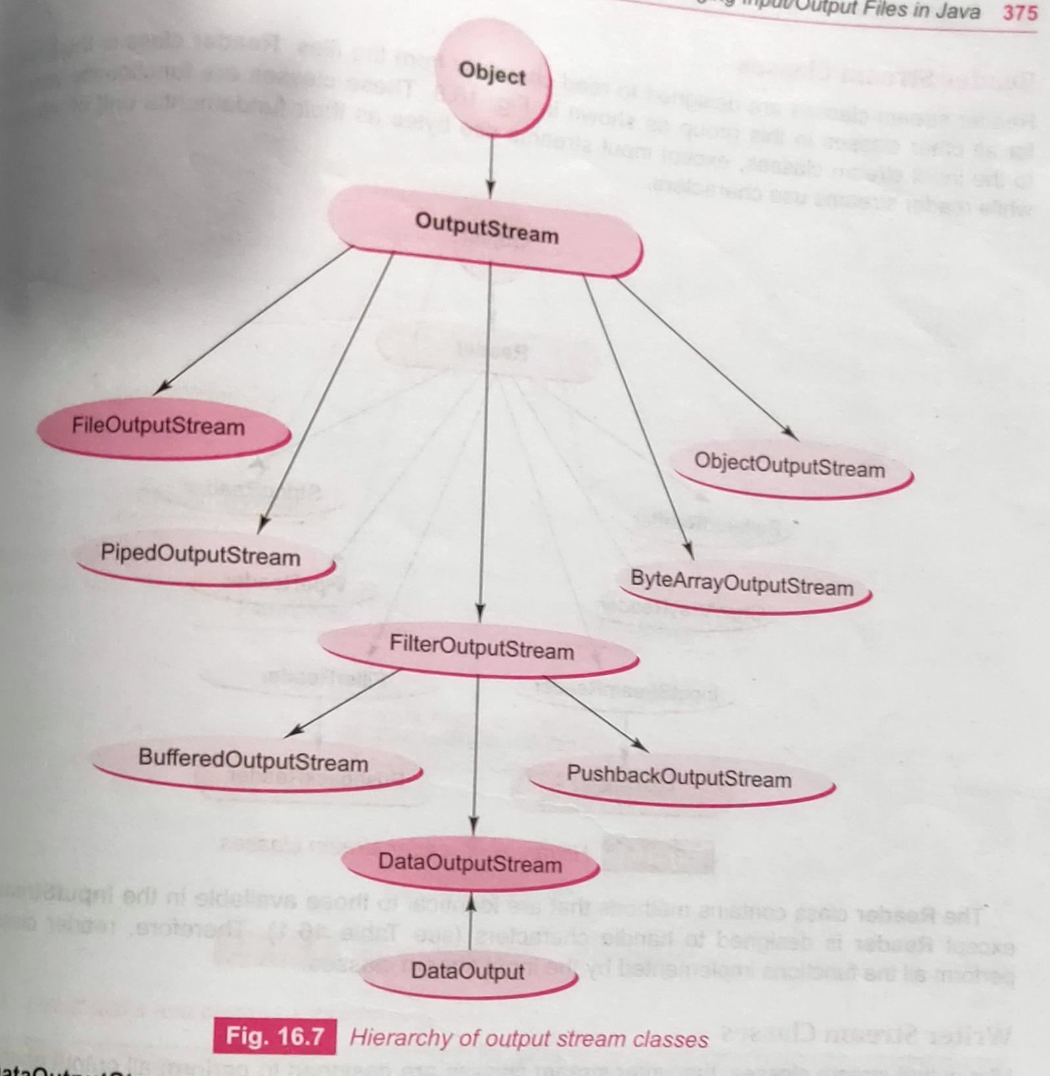

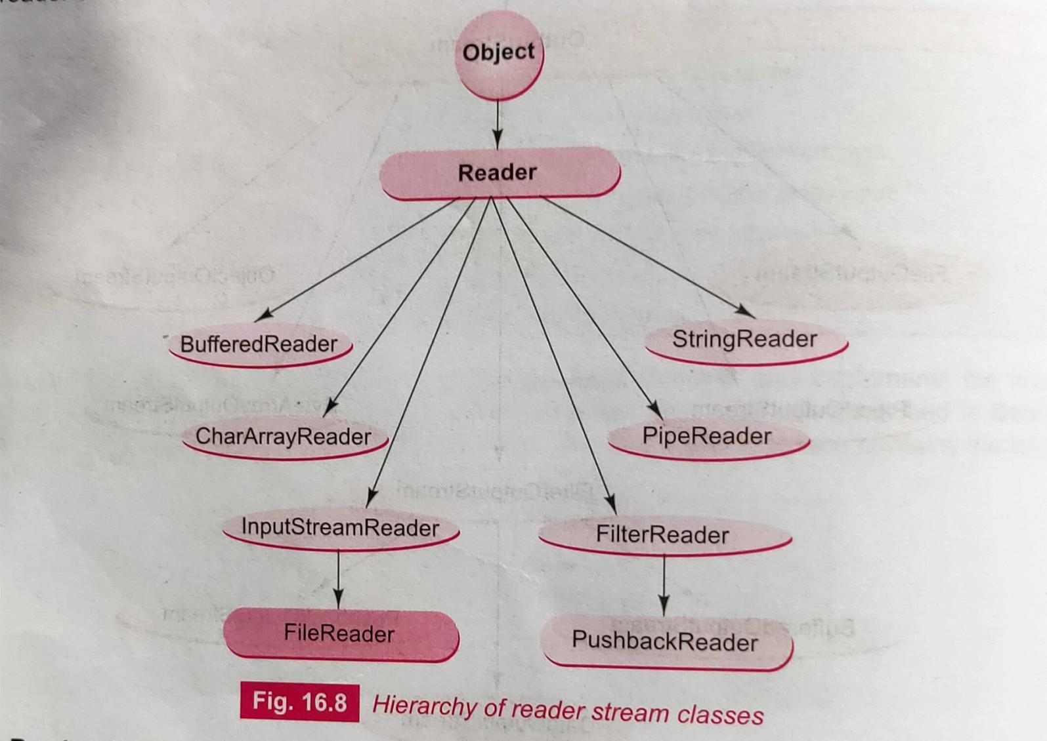

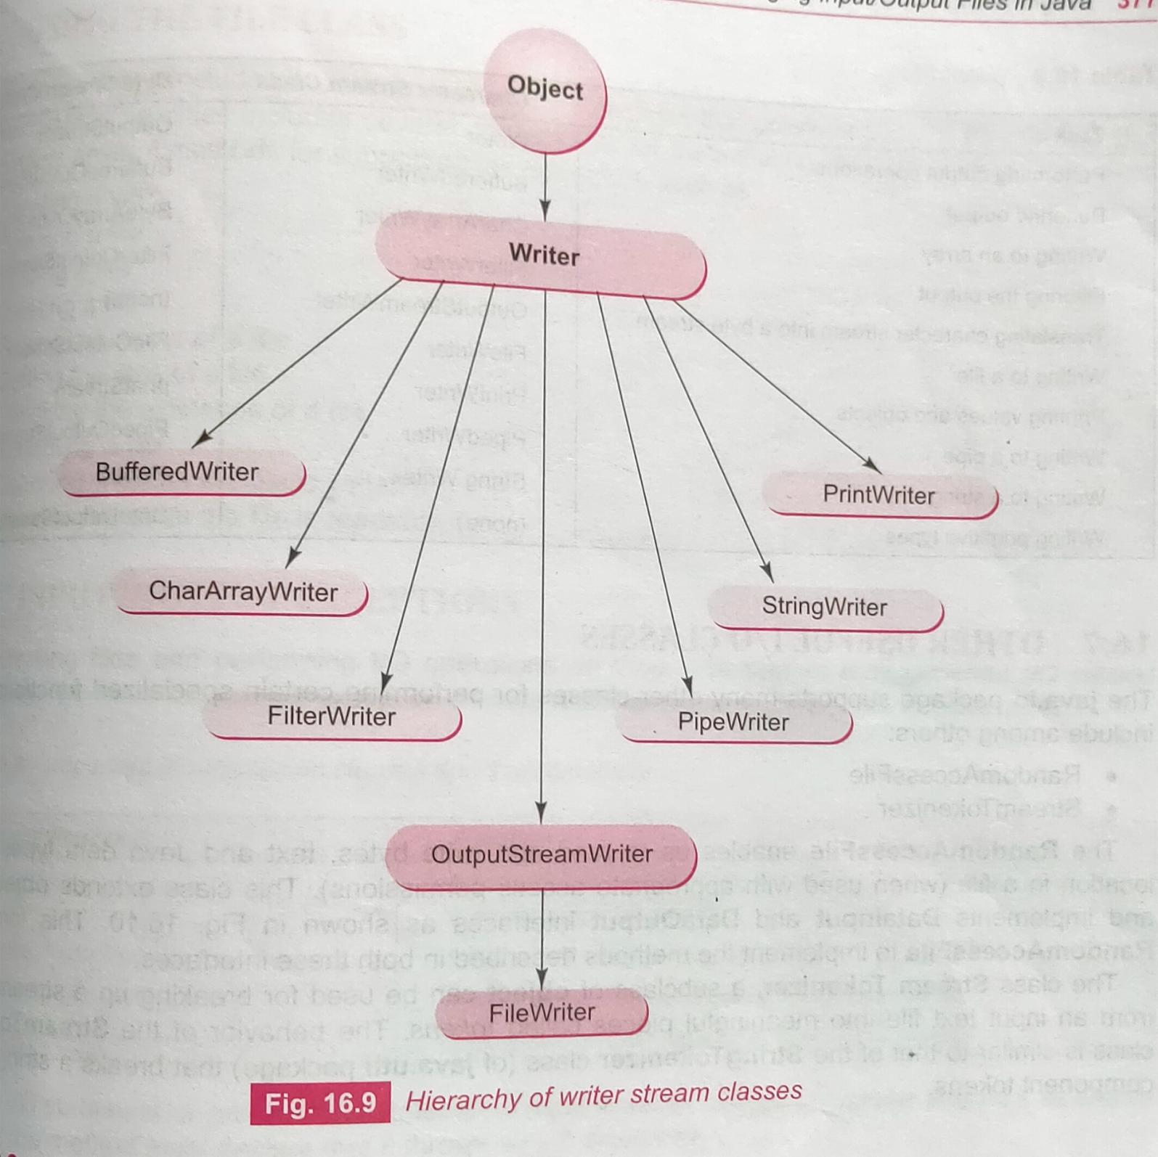j

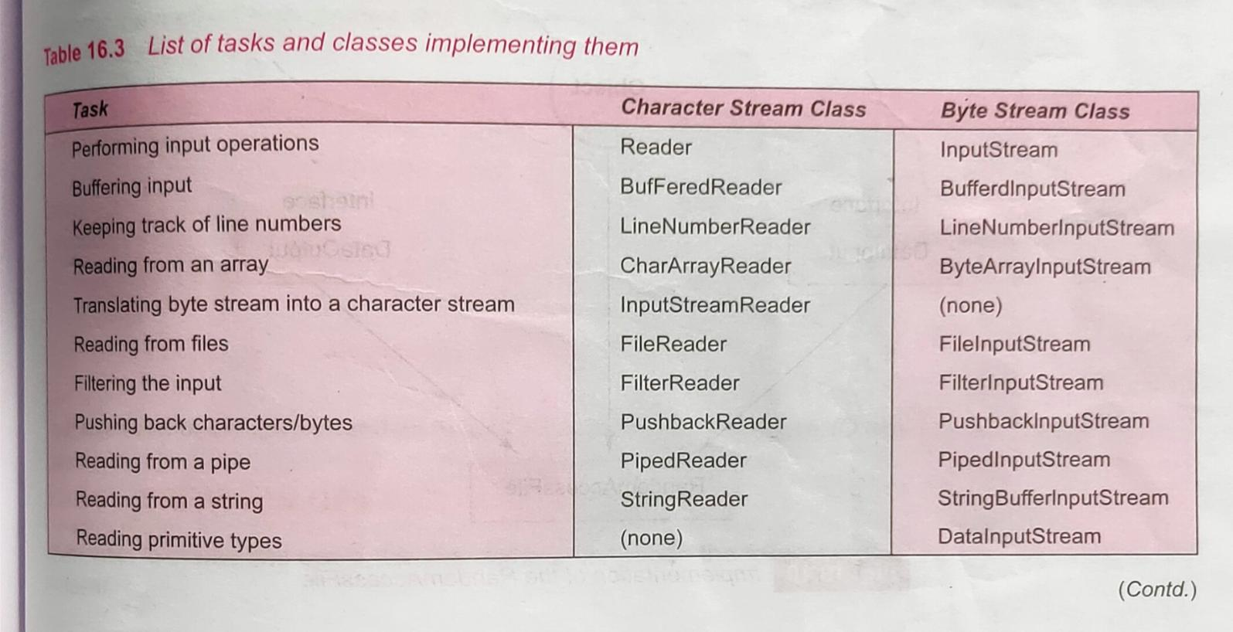

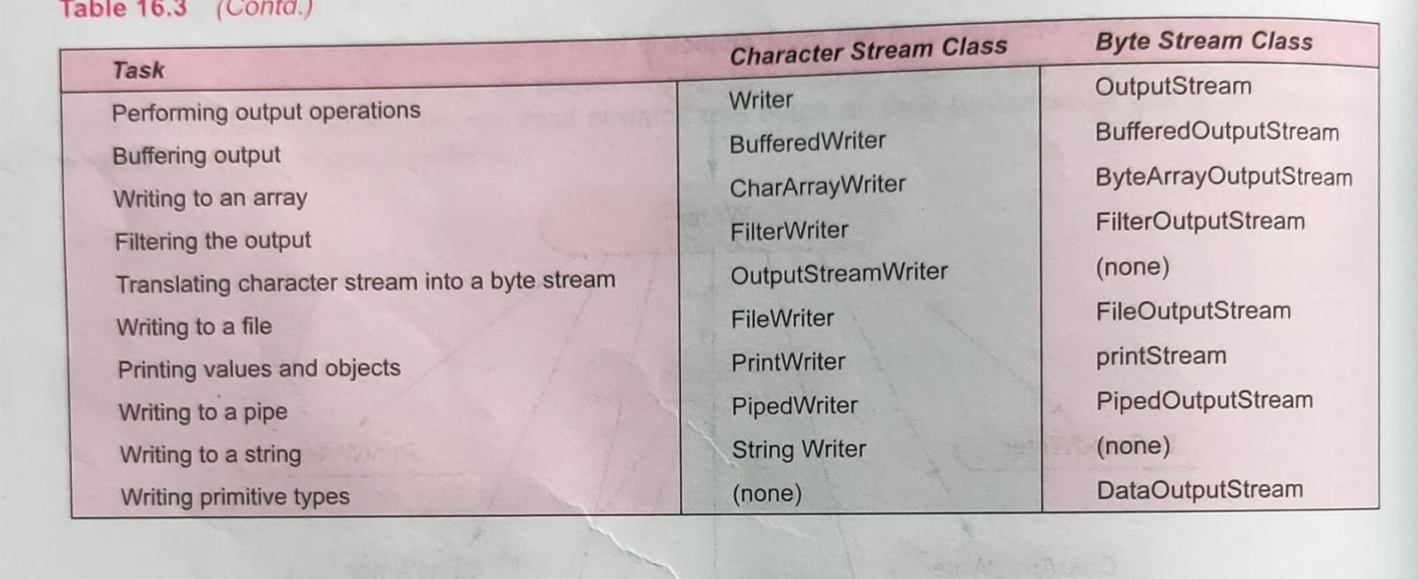

//Create File

import java.io.*;

class CreateFile

{

    public static void main(String[] args)

    {

        try

        {

            File file = new File("myFile.txt");

            if (file.createNewFile())

               System.out.println(file.getName()+ " is created");

            else

               System.out.println("File is already exists");

        }

        catch(IOException e)

        {

            System.out.println(e);

        }

    }

}

//Create Directory

import java.io.File;

//Create Directory

class MakeDirectory

{

    public static void main(String[] args)

    {

        File dir = new File("MyDir");

        // File dir = new File("C:/Users/MyDir");

        dir.mkdir();

        // dir.delete();

        String abs_path=dir.getAbsolutePath();

        String name = dir.getName();

        System.out.println("abs_path: "+abs_path);

        System.out.println("name: "+name);

    }

}

//Read Character from File

import java.io.*;

public class ReadCharToFile

{

    public static void main(String[] args)

    {

        FileReader fr=null;

        String s; //String a sequence of characters  char [] ch

        int i;

        try

        {

            fr = new FileReader("myFile1.txt");

            while ((i=fr.read()) != -1)

            {

                System.out.print((char)i);

            }

        }

        catch(IOException e)

        {

            System.err.println(e);

        }

        finally

        {

            try

            {

                fr.close();

            }

            catch(IOException e)

            {

                System.err.println(e);

            }

        }

    }

}

Output:

NAME: Tanmay Roy

Roll: 32

//Write Character to File

import java.io.*;

public class WriteCharToFile

{

    public static void main(String[] args)

    {

        FileWriter fw = null;

        // char ch;

        String s;

        try

        {

            fw = new FileWriter("myFile1.txt");

            s="NAME: Tanmay Roy\nRoll: 32";

            // ch = 'a';

            fw.write(s);

            // fw.write(ch);

        }

        catch(IOException e)

        {

            System.err.println(e.getStackTrace());

        }

        finally

        {

            try

            {

                fw.close();

            }

            catch(IOException e)

            {

                System.err.println(e);

            }

        }

    }

}

//Read byte from File

import java.io.*;

class ReadByteFromFile

{

    public static void main(String[] args) //throws IOException

    {

        FileInputStream infile = null;

        int i;

        try

        {

            // File f = new File("myFile");

            infile = new FileInputStream("myFile1.txt");

            while ((i=infile.read()) != -1)

            {

                System.out.print((char)i);

            }

        }

        catch(IOException e)

        {

            System.err.println(e);

        }

        finally

        {

            try

            {

                infile.close();

            }

            catch(IOException e)

            {

                System.out.println(e);

            }

        }

    }

}

//Write byte to File

import java.io.*;

class WriteByteToFile

{

    public static void main(String[] args) //throws IOException

    {

        try

        {

            // File f = new File("myFile");

            FileOutputStream outfile = new FileOutputStream("myFile.txt");

            String s = "Name: Tanmay Samanta\nAge: 21";

            byte [] b = s.getBytes();

            // byte [] b = {65,66,67};

            //           A  B  C

            outfile.write(b);

            outfile.close();

        }

        catch(IOException e)

        {

            System.err.println(e);

        }

    }

}

//Random access the contains of a file

import java.io.*;

public class RandomAccessFileTest {

    public static void main(String[] args)

    {

        RandomAccessFile raf = null;

        int i;

        try

        {

            raf = new RandomAccessFile("myFile1.txt","rw");

            for (int a=0;a<=raf.length();a+=2)

            {

                raf.seek(a);

                i=raf.read();

                System.out.print((char)i);

            }

        }

        catch(IOException e)

        {

            System.err.println(e);

        }

        finally

        {

            try

            {

                raf.close();

            }

            catch(IOException e)

            {

                System.err.println(e.getStackTrace());

            }

        }

    }

}

Contain of myFile1.txt

NAME: Tanmay Roy

Roll: 32

***Output:***

NM:Tna o

ol 2

MCA 2011-12 MAKAUT

Write a program in java that takes a file name and a search string from the user. If the search string occurs in the file, then it counts the number of occurrences of the string. (Assume that search pattern can exist more than two times in a line).

/*

 2011-12

 Write a program in java that takes a file name and a search

 string from the user. If the search string occurs in the

 file, then it counts the number of occurrences of the string.

 (Assume that search pattern can exist more than two times in a line).

 */

 import java.io.BufferedReader;

 import java.io.File;

 import java.io.FileReader;

 import java.io.IOException;

 public class CountOccurrencesOfStringInFile {

     public static void main(String[] args) throws IOException {

         // Get the file name and search string from the user.

         System.out.print("Enter the file name: ");

         String fileName = System.console().readLine();

         System.out.print("Enter the search string: ");

         String searchString = System.console().readLine();

         // Create a File object for the file.

         File file = new File(fileName);

         // Create a BufferedReader object to read the file.

         BufferedReader bufferedReader = new BufferedReader(new FileReader(file));

         // Initialize the count of occurrences to 0.

         int count = 0;

         // Read each line from the file.

         String line;

         while ((line = bufferedReader.readLine()) != null) {

             // Find the index of the search string in the line.

             int index = line.indexOf(searchString);

             // If the search string is found in the line, increment the count.

             while (index != -1) {

                 count++;

                 index = line.indexOf(searchString, index + searchString.length());

             }

         }

         // Close the BufferedReader object.

         bufferedReader.close();

         // Print the number of occurrences of the search string.

         System.out.println("The search string \"" + searchString + "\" appears " + count + " times in the file.");

     }

 }

Contain of myFile1.txt

NAME: Tanmay Roy

Roll: 32 Roy

***Output:***

Enter the search string: Roy

The search string "Roy" appears 2 times in the file.

*Serializtion & De-Serializtion:*

Serialization is a mechanism of converting the state of an object into a byte stream.

Deserialization is the reverse process where the byte stream is used to recreate the actual Java object in memory.

This mechanism is used to persist the object.

 It is mainly used in Hibernate, RMI, JPA, EJB and JMS technologies.

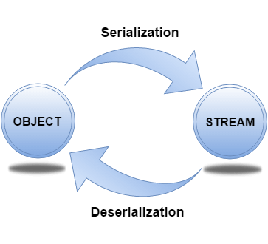

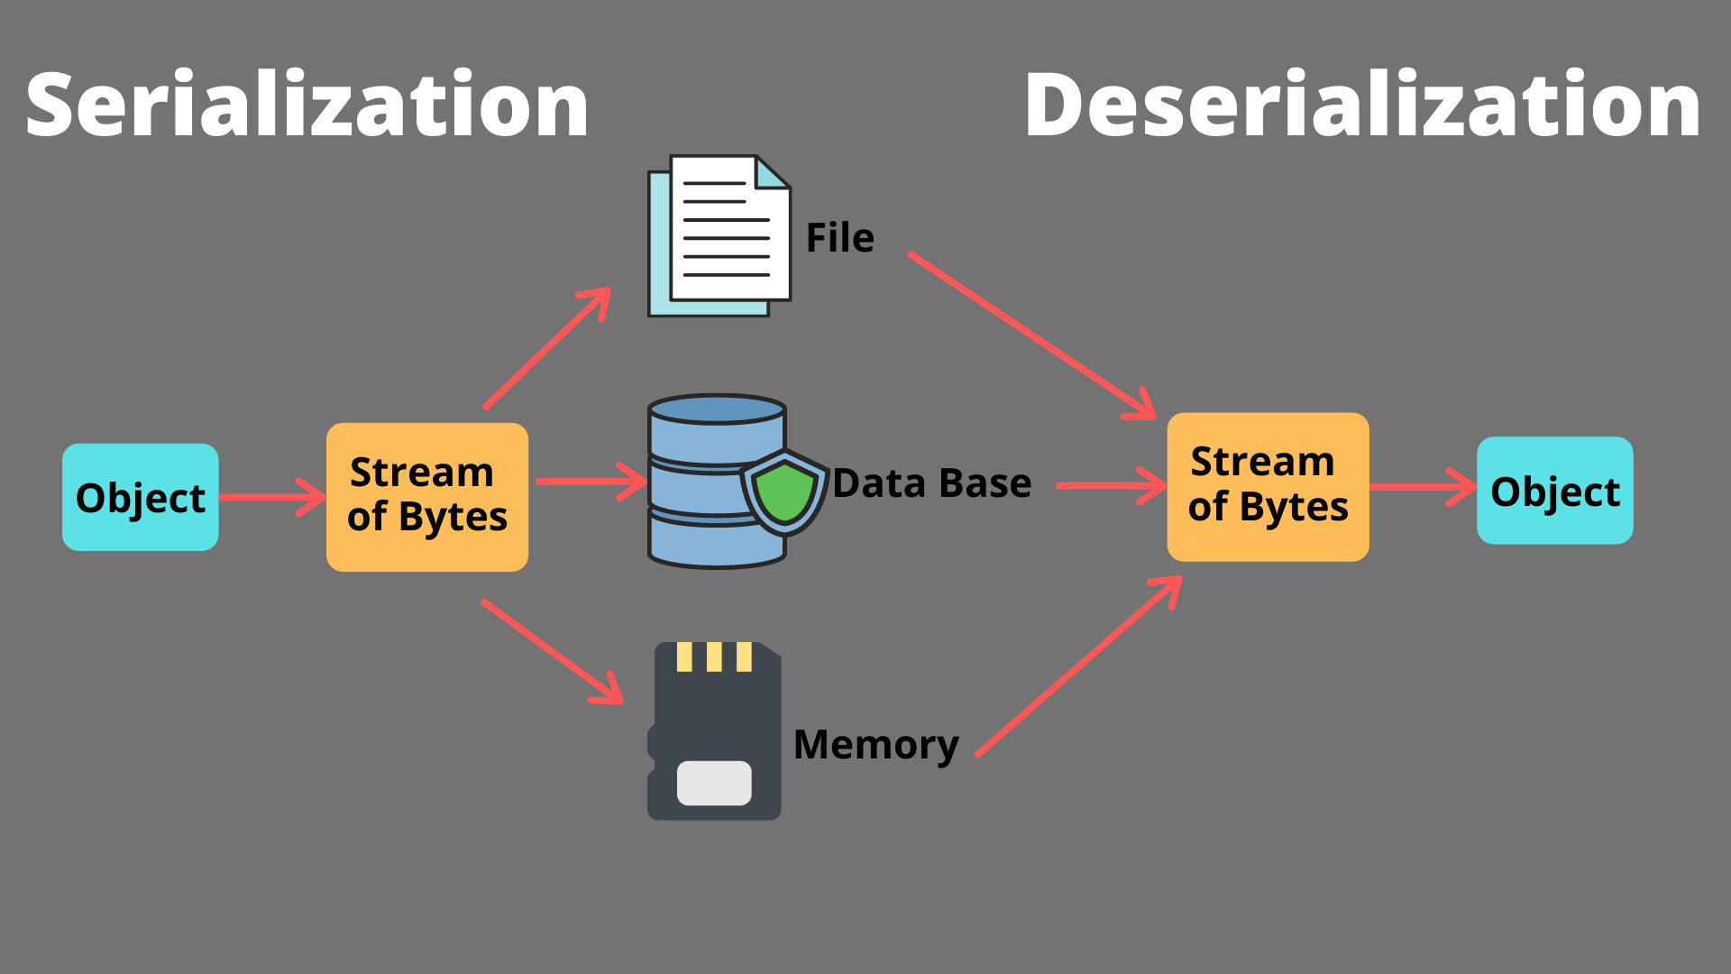

**Advantages of Serialization**

1. To save/persist state of an object.
2. To travel an object across a network.

***Example of Serialization:***

import java.io.Serializable;

public class Student implements Serializable

{

    int id;

    String name;

    public Student(int id, String name)

    {

        this.id = id;

        this.name = name;

    }

}

import java.io.*;

class Persist

{

    public static void main(String args[])throws Exception

    {

        Student s1 =new Student(211,"ravi");

        FileOutputStream fout=new FileOutputStream("f.txt");

        ObjectOutputStream out=new ObjectOutputStream(fout);

       out.writeObject(s1);

       out.flush();

       out.close();

       System.out.println("success");

    }

}

****Output:****

success

***Example of De-erialization:***

import java.io.Serializable;

public class Student implements Serializable

{

    int id;

    String name;

    public Student(int id, String name)

    {

        this.id = id;

        this.name = name;

    }

}

import java.io.*;

class DePersist

{

    public static void main(String args[])throws Exception

    {

        ObjectInputStream in=new ObjectInputStream(new FileInputStream("f.txt"));

        Student s=(Student)in.readObject();

        System.out.println(s.id+" "+s.name);

        in.close();

 }

}

****Output:****

success

211 ravi Engineering 50000